Sequence Diagrams

The remaining diagrams illustrate the steps taken behind the scenes for the use case to be carried out. The actor fills out and submits fields associated with their class and the object-oriented code communicates with the database or cloud. Then, feedback is provided to the program which gives visual feedback to the user.

AccessDatabaseRecords

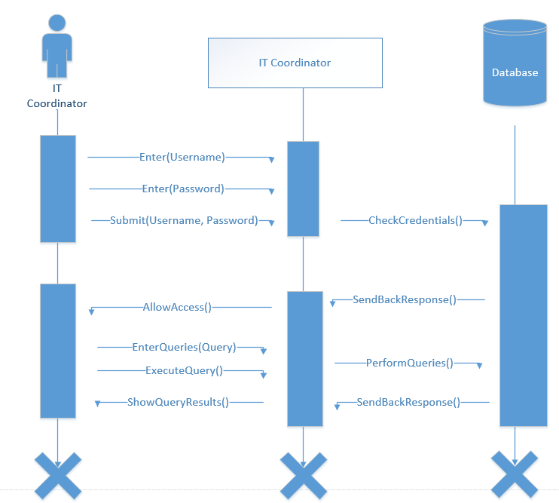

StoreDatabaseRecords

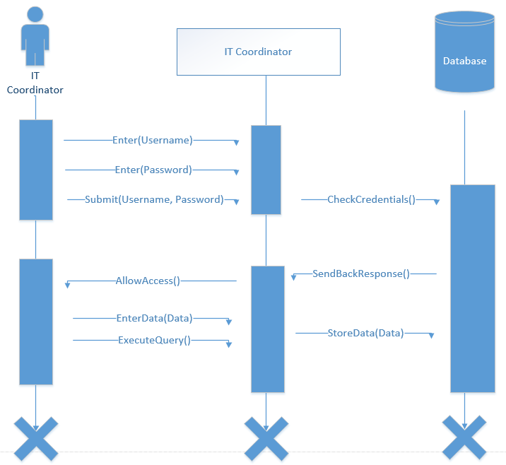

RecoverDatabaseRecords

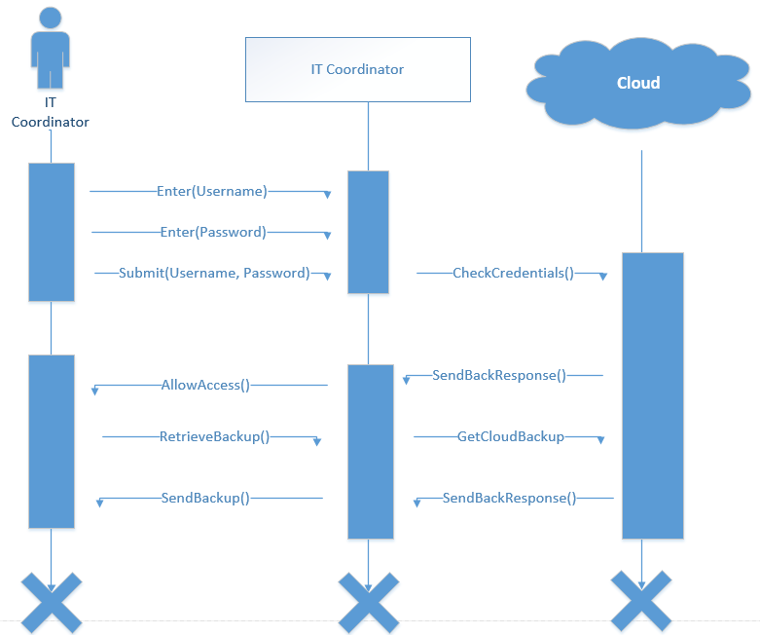

BackupDatabaseRecords

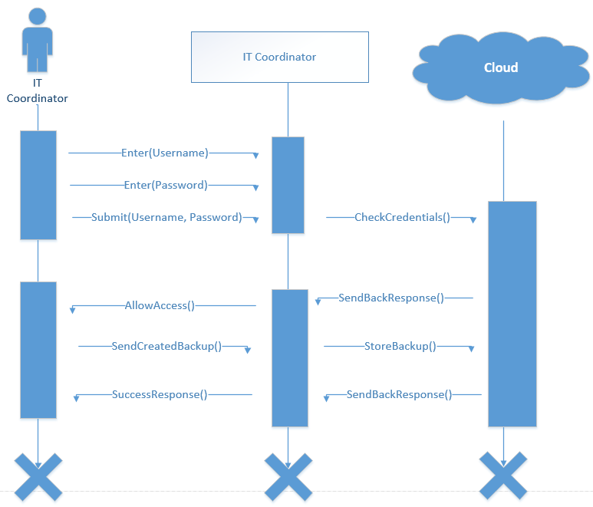

LoginAdminPortal

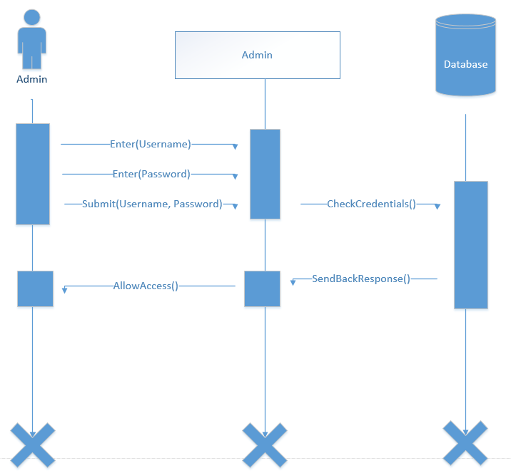

LoginVolunteers

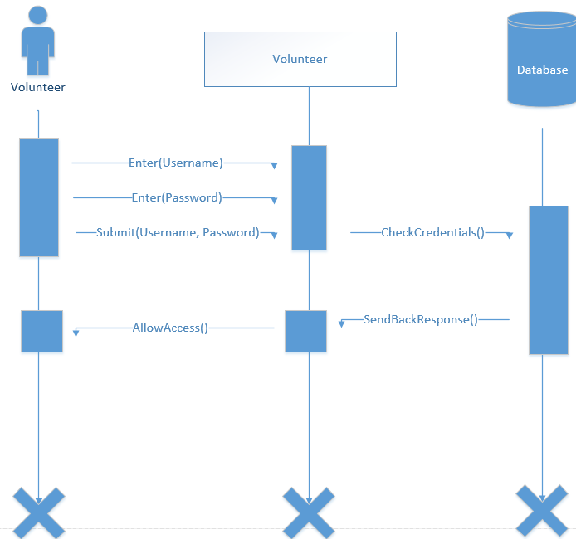

LoginDonors

